wTemasek Polytechnic
School of Informatics and IT

Diploma in Information Technology (IT)

Project Plan

Project Particulars

Tutor | Mel Goh
Class | P04
Project Title | Delonix Regia Hotel Management System

Project Team’s Particulars

Matric Number | Student Name
1404150C | Shaun Chua
1405306J | Parmesher Singh
1404555C | Quinones Mark Joseph

Revision History

Date | Version | Description | Author
<dd/mm/yy> | <x.x> | <details> | <name>

Table of Contents

- Introduction
  - Objectives and scope of the project
  - Assumptions and constraints
  - Definitions and acronyms

- Roles and responsibilities

- Estimates and project schedule
  - Work breakdown structure
  - Project schedule
  - Budget summary

- Risk management plan
Project Plan

1 Introduction
1.1 Objectives and scope of the project

The objective of the project is to help Mr and Mrs Wang whose hotel that isn’t doing very well by helping them to deliver a working system which could improve their business and . Some of the key features that will be developed is the booking of the hotel, the room details and the staff. At the end of the project we would expect that with our system, it would be easier for both the management of the hotel and customer to book the hotel and also other information like room details. Additionally we would also ensure that our system would be made to perfection and have as few errors as possible where we as a team would look into it to ensure it is suitable for the hotel.

1.2 Assumptions and constraints

There isn’t any assumptions made. For the delivery date of the system we are given 7 weeks to do and therefore there may still be a little error in the overall project and for the hardware or software availability, we are using visual studio and fiddler and so although all of our team members are able to use it there still may be some problems which some laptop would have which would give us less time to make this system to perfection.

1.3 Definitions and acronyms

We would regularly check each other work and ensure that everybody is on the right track and we would help one another if there are any problems faced so as to ensure we are able to finish this system as fast as we can with no errors and made sure everybody understood what we are suppose to do.

2 Roles and responsibilities

Name | Roles
Shaun Chua | Analysis and requirement gathering
Parmesher Singh | System development, testing and deployment.
Quinones Mark Joseph | Design, testing and development

3 Estimates and project schedule
3.1 Work breakdown structure

Name | Task
Mark Joseph | Project Initiation  - Determine project objectives  - Create a project charter  - Meeting with project sponsors or stake holders  - Assign project team  - Determine project budget  - Distribute workload  Estimated days to complete = 2 days
Shaun Chua | Requirement Gathering & Analysis  - Interview manager  - Gather requirements from stake holders  - Research on existing systems  - Review competitors  - Determine the scope of the project  - Prioritize features to implement  - Determine software and hardware needs  - Sourcing of components  - Scheduling of delivery  Estimated days to complete = 8 days
Parmesher Singh | System Design & Development  - Develop multiple architecture for the project  - Review software specs  - Propose various architecture  - Document proposal  - Develop Code  - Debugging of system  - Presentation of product for approval  - Assigning development staff  Estimated days to complete = 26 days
Parmesher Singh | Testing  - Unit testing  - Integration testing  - System testing  - Acceptance testing  - Non-functional testing  Estimated days to complete = 2
Mark Joseph | Deployment and Maintenance  - Provide beta testing  - Provide feedback to engineering team if there are problems  - Deploy the system  - Open channel for customers to provide feedback  - Solve any problems that user encounter  Estimated days to complete = 10

3.2 Project Schedule
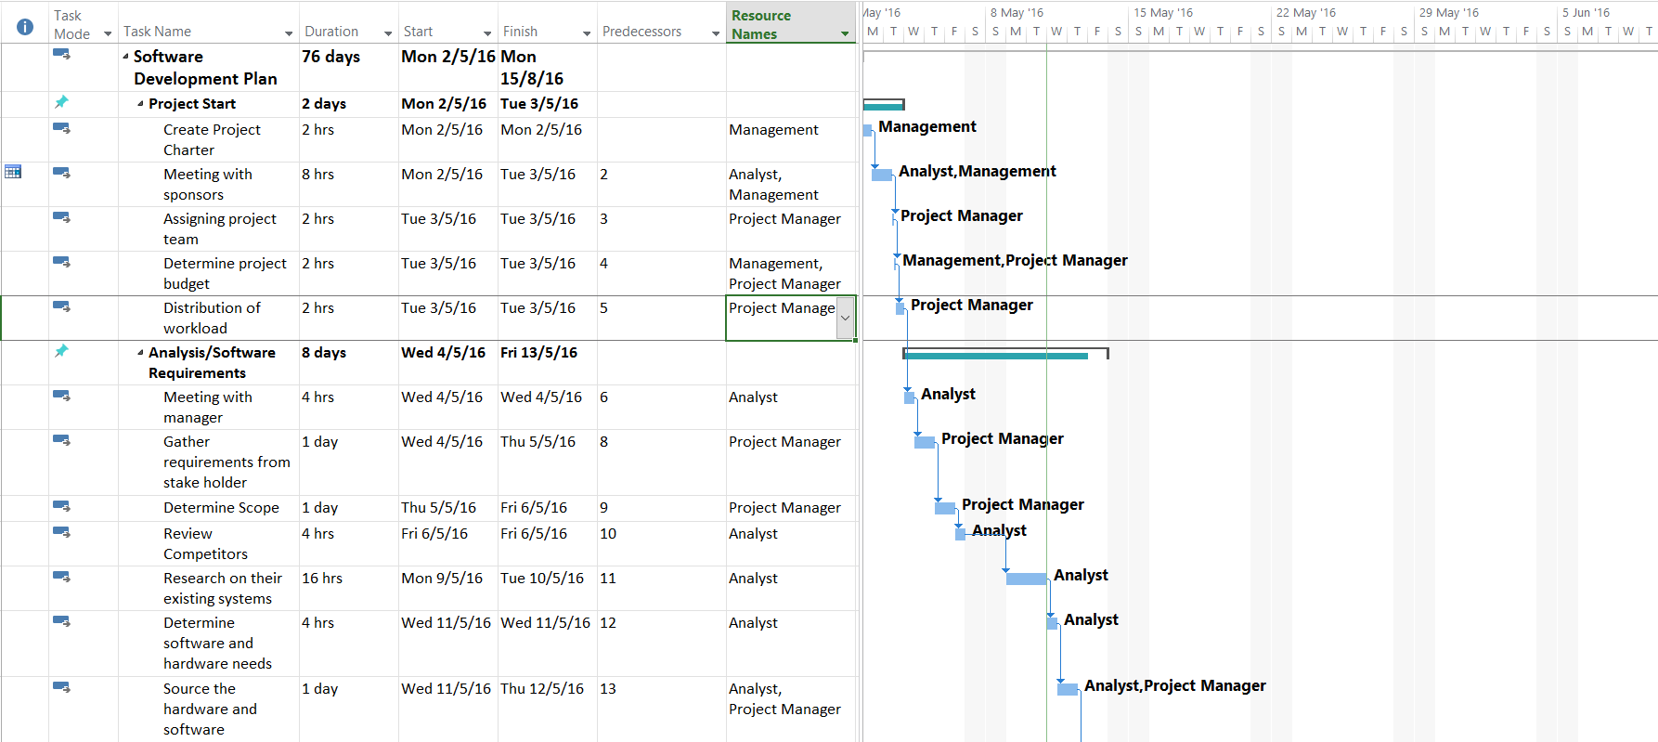
Figure 1
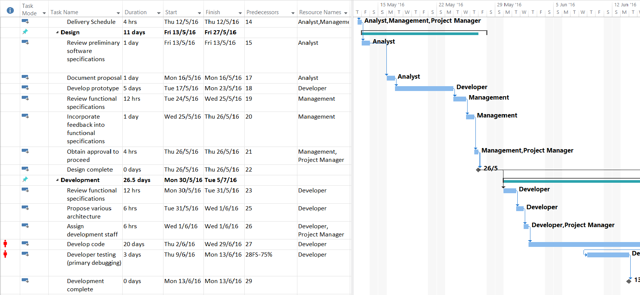
Figure 2

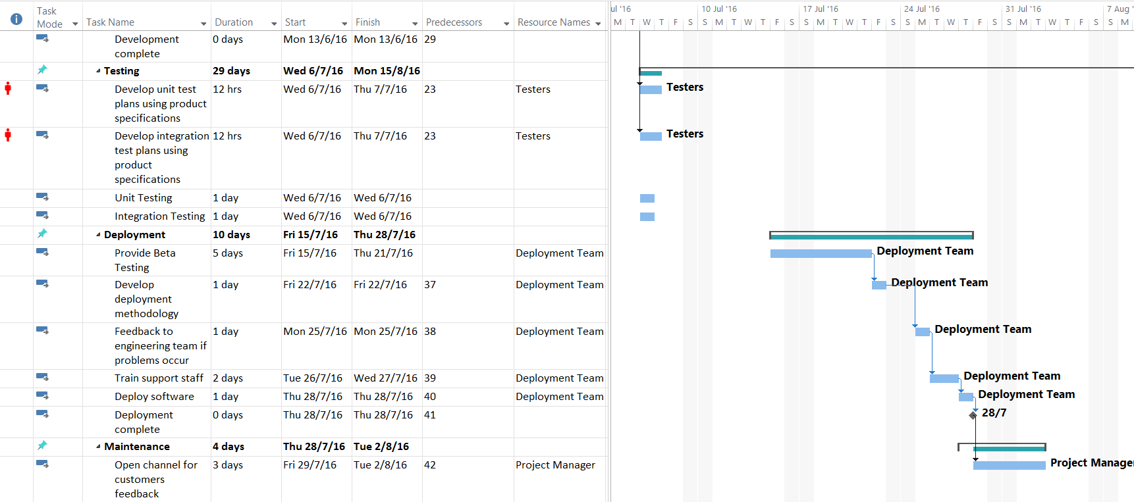
Figure 3

3.3 Budget Summary

The monthly salary of a typical software engineer is $4000 and there are three members in the development team. The duration of the project is 6 weeks. So the total salaries for the three members will amount to $18000. The hardware consists of 3 laptops and a printer. That would add up to $4000. As for the software costs, we will be receiving the software free of charge. The total expenses for this project will amount to $22,000.

4 Risk Management Plan

There are several possible project risks that might occur during the project.

One of the most common risks is known as user involvement. This is where if users are not active in the involvement of the project, the project requirements and specification might be then modified during the course of the project. This causes significant delay in the execution of the project and the costs of the project unknowingly increases. The likelihood of this risk arising is quite high.

In order to avoid this from occurring or not worsening the situation, the users or team members have to be involved early in the project. Updates about their progress and expectations should be carried out at a consistent rate.

Another possible project risk is known as requirements inflation. As mentioned earlier, the lack of involvement of the team members in the project can prove to be costly. But there is another reason as to why requirements inflation occurs. The cause is better known as Gold Plating. This is where the team in charge of developing the project would want to be equipped with stellar commodities and start having small add-ons to their product in the process of developing it. As a result, these little add-ons will be unavailable to be carried out according to the project schedule. Users will find that their specifications are not being met by the development team. Another thing to take note is that when these add-ons are being implemented, the chances of the project not working out will be higher and higher.

In order to avoid being a victim of Gold Plating, the development team need to come to a consensus when they want to add extra features or make small changes. The members of the development team need to justify their actions as to why they have made changes and also whether extra time will be needed to complete the project.

Another possible project risk is known as schedule flaws. There are many reasons as to why schedule flaws occur. Some examples are lack of knowledge or the project deliverables or misjudging the end date of the project. But the biggest reason why schedules tend to be improper is because the schedule has been prepared based on the best way possible. Obviously, setbacks and problems are bound to occur. The schedule has been planned with the thought that no problems will occur during the course of the project and everything will fall into place.

In order to the minimize the impact of the schedule being flawed, a pragmatic, attainable schedule with some sort of risk consideration is a must. Consider those risks and make changes to the schedule accordingly. Also, it makes sense to ask the team to give a rough approximation of the project duration since they will be the ones who will doing the work.

Another possible project risk is known as employee turnover. This is where employees leave the company and the vacant positions are filled by new employees. This kind of displacement can cause loads of disruption and unrest in the company. The project will come to a standstill as other matters have to be resolved which would then result in the project either not being delivered properly or it being shelved. The likelihood of this happening is very high as it is normal for companies to bring in new employees after the old ones are no longer associated with them.

In order to improve the situation, contingency policies should be implemented. Another way is to come up with a cross training plan should be carried out. An example of where the cross training plan comes in handy is when a member of the development team has left the company, so this should be addressed in the risk management plan and make it clear that drastic changes in staff will cause an impact on the schedule and possibly even the budget of the project. Also, the new employee which has been joined the project team will need time to be familiar with the situation of the project which will most likely cause a slight delay.

